Chapter 9, Problem 73.

Determine the equivalent impedance of the circuit in Fig. 9.80.

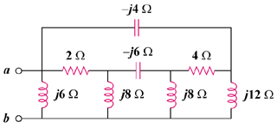

Figure 9.80
For Prob. 9.73.

